SECTION 5.2:

1.

**Code:**

import java.util.HashMap;

import java.util.Map;

import java.util.Scanner;

public class DecodeMessage {

public static void main(String[] args) {

Map<Integer, Character> codeMap = new HashMap<>();

codeMap.put(1, 'D');

codeMap.put(2, 'W');

codeMap.put(3, 'E');

codeMap.put(4, 'L');

codeMap.put(5, 'H');

codeMap.put(6, 'O');

codeMap.put(7, 'R');

Scanner scanner = new Scanner(System.in);

StringBuilder decodedMessage = new StringBuilder();

System.out.println("Enter 10 numbers (1-7) to decode the message:");

for (int i = 0; i < 10; i++) {

while (true) {

System.out.print("Enter a number: ");

int num = scanner.nextInt();

if (codeMap.containsKey(num)) {

decodedMessage.append(codeMap.get(num));

break;

} else {

System.out.println("Invalid number. Please enter a number between 1 and 7.");

}

}

}

System.out.println("Decoded message: " + decodedMessage.toString());

}

}

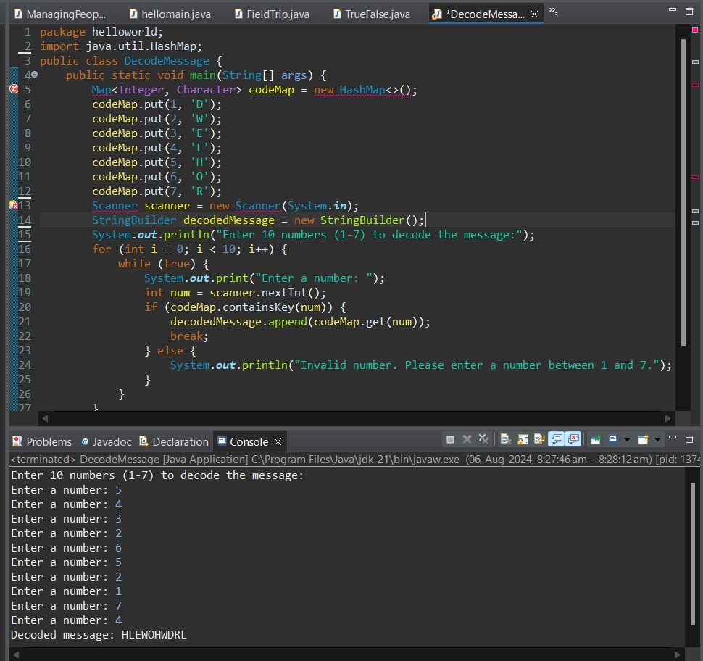

2.

**Code:**

public class SearchSpaceCharacter {

public static void main(String[] args) {

String str = "Hello World";

int index = 0;

while (index < str.length()) {

if (str.charAt(index) == ' ') {

System.out.println("Space character found at index: " + index);

break;

}

index++;

}

if (index == str.length()) {

System.out.println("No space character found in the string.");

}

}

}

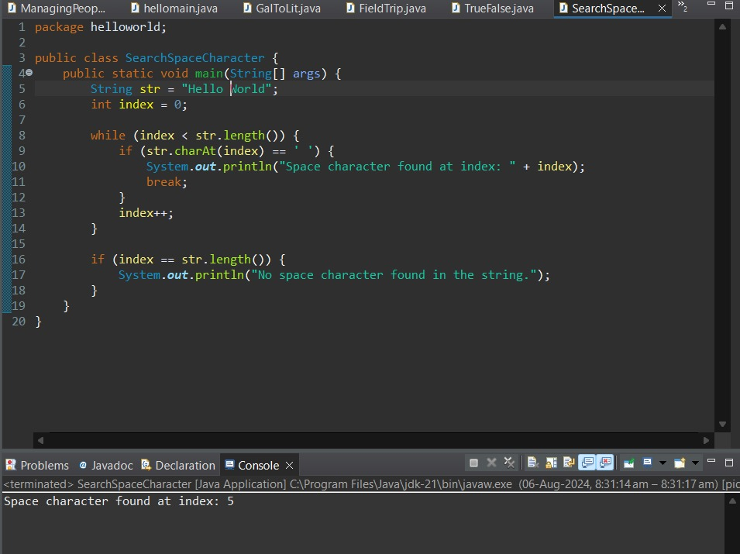

3.

**Code:**

public class PrintDaysOfWeek {

public static void main(String[] args) {

String[] days = {"Sunday", "Monday", "Tuesday", "Wednesday", "Thursday", "Friday", "Saturday"};

int dayIndex = 0;

for (int day = 1; day <= 365; day++) {

System.out.println("Day " + day + ": " + days[dayIndex]);

dayIndex = (dayIndex + 1) % 7;

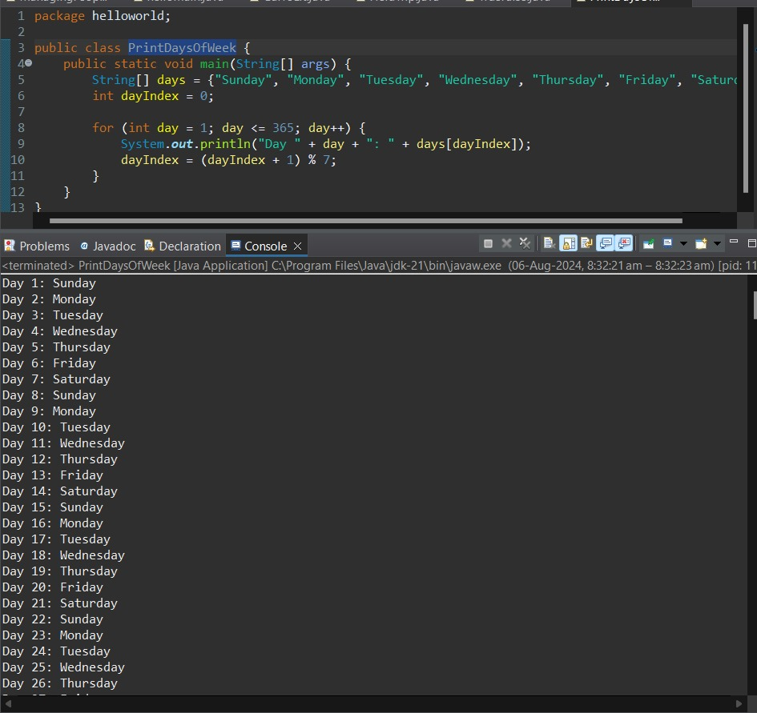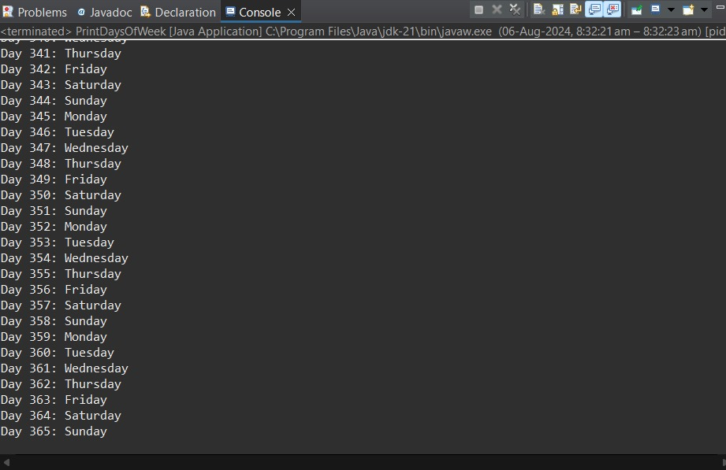

4

**Code:**

import java.util.Arrays;

public class AnagramChecker {

public static void main(String[] args) {

System.out.println(areAnagrams("parliament", "partial men")); // Output: true

System.out.println(areAnagrams("software", "swear oft")); // Output: true

System.out.println(areAnagrams("hello", "world")); // Output: false

}

public static boolean areAnagrams(String str1, String str2) {

// Remove whitespace and punctuation, convert to lowercase

str1 = str1.replaceAll("\\W+", "").toLowerCase();

str2 = str2.replaceAll("\\W+", "").toLowerCase();

// Convert strings to char arrays and sort

char[] charArray1 = str1.toCharArray();

char[] charArray2 = str2.toCharArray();

Arrays.sort(charArray1);

Arrays.sort(charArray2);

// Compare sorted char arrays

return Arrays.equals(charArray1, charArray2);

}

}

